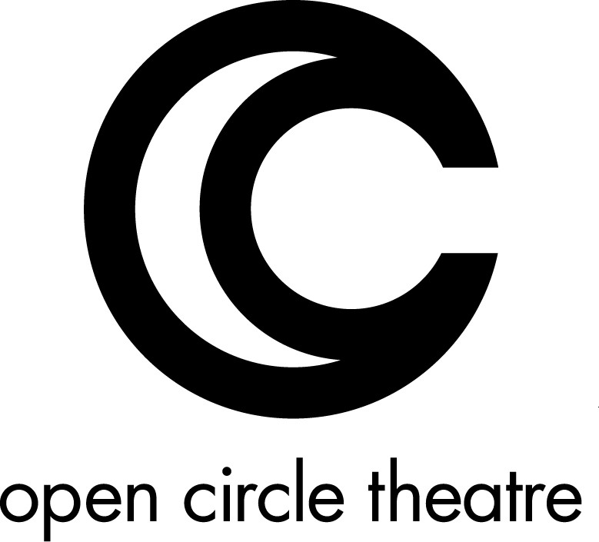

BOARD
http://opencircletheatre.org/home/board-staff/

Board of Directors

President - Suzanne Richard
SUZANNE RICHARD has a BA in Dramatic Arts from the University of North Carolina at Chapel Hill. With Open Circle Theatre she received a Helen Hayes nomination for Outstanding Direction and Outstanding Production of a Resident Musical for Jesus Christ Superstar. She currently works as a professional actress in the DC area with such companies as The Folger, Fords Theatre, Washington Shakespeare Company, Imagination Stage, and 1st Stage. She also works as a consultant to the U.S. International Council on Disabilities, where she was previously the Outreach Coordinator, and as a Program Partner and Master Teaching Artist with Story Tapestries. At the National Endowment for the Arts, she served as the Accessibility Specialist in the Office of AccessAbility. She served on the Maryland Governor’s Advisory Committee for Genetic and Heritable Disorders and the Governor’s Advisory Committee for Careers in the Arts for Persons with DisAbilities. Along with frequently speaking on disAbility issues and genetics for the Human Genome Project, she authored the chapter “Dealing with Being Different” for Growing Up with Osteogenesis Imperfecta along with chapters in various books on arts and disabilities.

Vice President - Elena Widder
ELENA WIDDER is a producer and arts administrator in the Washington, DC area. The bulk of her 35-year career was spent at VSA, the international organization for arts and disability, an affiliate of the John F. Kennedy Center for the Performing Arts. As VSA’s Director of Performing Arts and then Vice President of Public Awareness, Ms. Widder produced dozens of plays as well as music and dance concerts at venues such as the Kennedy Center, the Harman Center, H Street Playhouse, and off-Broadway. She has commissioned new work in collaboration with Dance Exchange (DC), Tamar Rogoff Performance Projects (NYC), and Ping Chong & Company (NYC). Earlier in her career, she was Administrative Director for the American Theatre Association. Ms. Widder also served two 3-year terms as a Helen Hayes Awards judge.

Treasurer - Jean-Paul Richard
JEAN-PAUL RICHARD is Vice President of Sid Jaffe & Associates, LLC (SJ&A), a team that provides business advisory support, and has worked in the information technology field for 35 years since receiving his MS from MIT’s Sloan School of Management. He is the former President of the Osteogenesis Imperfecta Foundation and was an original board member of the Genetic Alliance. He has served as treasurer for the Genetic Alliance, HOW: Handicapped’s Only a Word, and the Coalition for Heritable Disorders of Connective Tissue.
Advisory Board Chair - Rob McQuay
ROB MCQUAY has broken the traditional typecasting of “wheelchair actors,” demonstrating to fellow actors and audiences alike the importance of focusing on abilities rather than disabilities. Attesting to this, he has performed at The Shakespeare Theatre, Annapolis Shakespeare Company, The Olney Theatre Center, Signature Theatre, Rep Stage, Everyman Theatre, Woolly Mammoth Theatre Company, Roundhouse Theatre, Imagination Stage, Open Circle Theatre, Theatre on The Hill, and the VSA Young Playwrights Program at the John F. Kennedy Center for the Performing Arts. Rob has also performed at Toby’s Dinner Theatre, Burnbrae Dinner Theatre, West End Dinner Theatre, The Hayloft Dinner Theatre, Towsontowne Dinner Theatre, Fells Point Dinner Theatre, Drury Lane Theatre in Chicago, and Center Stage in Baltimore. On the small screen, Rob has been seen in the TV series, Trinity, with Danny Aiello in his series Dellaventura, and as the spokesman for the National Rehabilitation Hospital. Moreover, his portrayal of Dolittle in “Dr. Dolittle” (Imagination Stage), Jesus in “Godspell” (The Roundhouse Theatre), Tateh in “Ragtime: The Musical” (Toby’s), and Jesus in Jesus Christ Superstar (Open Circle Theatre) have earned him Helen Hayes Nominations for Outstanding Lead Actor in a Musical. Rob also earned a Helen Hayes Nomination for Outstanding Direction of a Musical for Godspell at Toby’s Dinner Theatre.

After a swimming accident left him a paraplegic, Rob began taking on disability advocacy while he worked at the National Endowment For The Arts. From there Rob has gone on to be the Chairman of the Governor’s Advisory Committee for Careers in the Arts for People with Disabilites (Maryland), earned the County Executive Outstanding Award, The Victory Award (NRH), and has served on Panels and discussion groups for the West Virginia Division of Culture & History, WV Commission on the Arts, and VSA Arts. Rob is an ordained minister.

Members At Large

SID JAFFE is CEO of Sid Jaffe & Associates, LLC (SJ&A), a team that provides business advisory support. Since 1992 the firm has supported more than 1,300 client firms worldwide, primarily in the federal government contracting and non–profit arenas. Sid is a regular speaker at Washington—as well as national—industry events; he brings currency in the marketplace, solid lessons learned, and a robust network. He has been a featured guest on nationally televised business shows. Receiving the prestigious Meritorious Service Award from the international organization of the Association for Corporate Growth (ACG), a premier M&A organization, Sid has served on the International Board of ACG, as well as Past-President of ACG’s National Capital Chapter. Sid serves on the Tower Club Advisory Board of Governors. He is a lifelong DC area resident. He and his family are active the community. He served as a past Board member of the Northern Virginia Habitat for Humanity and is a 24 year member of the Falls Church – Annandale Lions Club Charities, Inc. He is active with Homes for our Troops, supporting disabled veterans.

HARV LESTER is an attorney who has litigated a variety of federal government contract claims – from relatively simple small-dollar claims to complex claims worth several billion dollars – in both the public and private sectors, first as an associate at Seyfarth Shaw LLP and then during a twenty-year tenure as a trial attorney and then an Assistant Branch Director with the Commercial Litigation Branch, Civil Division, United States Department of Justice. He now serves as a judge with an administrative board created by Congress that resolves similar claims by and against the Federal Government. In addition to that work, he is also a musical theater actor who has performed in the Capital Fringe and New York International Fringe Festivals and with various theaters in the Washington, D.C., area, including Signature Theatre, Creative Cauldron, WSC Avant Bard, and Keegan Theatre.

ARIANNA ROSS was Artistic Director of Scarlet Theatre Company in Chicago and directed “Mother Hicks” and “My Left Breast”. She also directed in the New Play Festival at the Source Theatre. Arianna trained in theatre, dance, voice, and design at Northwestern University in Illinois. She spent three years studying acrobatics, music, and martial arts and toured professionally all over India with Bansi Kaul’s troupe, Rang Vidushak. Arianna’s solo performances are created from her understanding of and experience in many different cultures worldwide. She tours as a solo storyteller all over the Washington Metropolitan area and works as the Arts Program Specialist for New Horizons, the Arts and Cultural Enrichment Program at Children’s National Medical Center.

JAY SHAPIRO

JOEL SNYDER, Ph.D. is President, Audio Description Associates, LLC and Director, Audio Description Project, American Council of the Blind (www.acb.org/adp). His awards include the 2014 Vernon Henley Media Award for promoting and furthering the availability of audio description and the Career Achievement Award in Audio Description of the American Council of the Blind. One of the first audio describers, Joel Snyder began describing theater events and media in 1981. A member of Actors' Equity Association, the American Federation of TV and Radio Artists, and the Screen Actors Guild, and a 20-year veteran of work as an arts specialist for the National Endowment for the Arts, is perhaps best known internationally as one of the first "audio describers."

Dr. Snyder is the author of many published articles on audio description and his book, "The Visual Made Verbal: A Comprehensive Training Manual and Guide to the History and Applications of Audio Description," was published by the American Council of the Blind in early 2014. Dr. Snyder holds a Ph.D. in Accessibility and Ambient Intelligence from the Universitat Autonoma de Barcelona.

STAFF

Artistic Director – Suzanne Richard
Financial Manager/Development Director – Monica Lijewski
Producer – Jen Bevan
Producer – Mikey Cafarelli
Publicity – Doretha “Doe” Dixon

