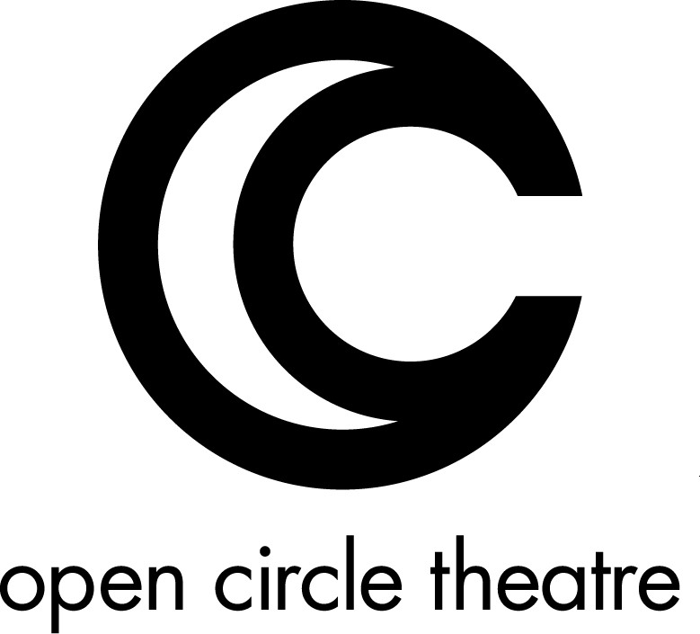

HISTORY

Founded in 1996, Open Circle Theatre Ensemble was a small company of friends that produced three original theatre pieces in Germantown, Maryland, then mounted a fourth original show at the Fringe Festival in Scotland. Although inclusion of artists with disabilities was not the original mission of Open Circle Theatre Ensemble, two company members happened to have disabilities. While considering mounting another production, Artistic Director Suzanne Richard realized that the original concept behind Open Circle Theatre Ensemble--leaving the circle around the campfire open to include the voices of all people--could be taken to another level while retaining the original spirit of the company. Open Circle would now focus on the work of one of the most underrepresented groups of storytellers--people with disabilities. A professional theatre artist with a disability herself, Suzanne Richard and co-founder Arianna Ross, a professional actor and storyteller, saw that there was a community of theatre artists with disabilities in the Washington, D.C. area, and decided to create a company where these artists could share their talents.

Born with a small production of Christopher Durang's "Laughing Wild" in 2003, Open Circle Theatre (OCT) is the brainchild of a group of theatre stakeholders--with and without disabilities--that share a passion for theatre, professional theatre credits, and a commitment to full access for all persons to every opportunity the D.C.-area theatrical community has to offer. OCT became the first theatre company in the Washington, D.C. metropolitan area dedicated to mounting professional theatre productions that showcase and integrate the considerable talents of performing artists with disabilities with those of their peers without disabilities.

In 2004, OCT presented Andrew Lloyd Webber and Tim Rice's "Jesus Christ Superstar" at the Washington Shakespeare Company's Clark Street Playhouse in Arlington, Virginia, where sixteen performances served some seven hundred patrons, and received excellent reviews in the Washington City Paper, Potomac Stages, and the Washington Post, which called the production "creative and refreshing." The show earned four Helen Hayes nominations, including Outstanding Resident Musical.

Over the next four years and five productions, Open Circle Theatre would garner positive reviews that reflected and understood precisely its mission:

Songs for a New World, 2007, directed by Suzanne Richard
"Watch, when Brown assembles a series of expansive chords at the end of a big number, how sign master Monique Holt and choreographers Shula Strassfel and Peter DiMuro stagger and stack the ensemble's gestures in a visual echo of the musical build--it's thrilling, and it makes you think about how many channels of communication we take for granted, and how many we usually overlook. Turns out a show driven by the idea of possibilities--of openings to new worlds--was a very fine choice indeed."
City Paper, 08/17/2007

Evita, 2006, directed by Joe Banno
"In creating little collisions of expectation and possibility, the troupe finds expressive, often exciting modes of communication that are less about limits overcome than about boundaries shattered—taking vocabularies or styles or images that wouldn’t exist but for those limits and those boundaries, fusing them with theatrical techniques both traditional and experimental, creating something that, at its best, is vital and energizing and new.”
City Paper, 08/16/2006
Jesus Christ Superstar, 2004, directed by Suzanne Richard
“Director Suzanne Richard found a way, without altering a word or a note, to give a freshness to this piece, make it surprisingly relevant to the moment, and, in the process, reveal the rock solid dramatic structure that underlies Rice's script….. They do it all with a staging that, due to Open Circle's approach of utilizing the abilities of artists with disabilities, is both unique and tremendously satisfying.”
Potomac Stage, 11/07/2004

MISSION

Open Circle Theatre is a place where theatre artists with and without disabilities can be mentored, receive training and have the opportunity to reach their professional potential. Open Circle Theatre utilizes the considerable talents of artists with disabilities to create professional theatrical productions and to provide outreach and educational programs that serve to expand the cultural and vocational opportunities for the residents of the Washington, D.C. community, with particular attention to people with disabilities.

